French at Stukeley Meadows

Subject Lead: Danielle Davis

[ddavis@stukeleymeadows.cambs.sch.uk](mailto:ddavis@stukeleymeadows.cambs.sch.uk)

Intent

From Summer 1 2024, Stukeley Meadows Primary School has been using the Language Angels scheme of work and resources to ensure we offer a relevant, broad, vibrant and ambitious French curriculum that will inspire and excite our pupils. The scheme uses a wide variety of topics and themes and the ultimate aim is that pupils will feel willing and able to continue studying languages beyond key stage 2.

The four key language learning skills; listening, speaking, reading and writing will be taught and all necessary grammar will be covered in an age-appropriate way across the primary phase. This will enable pupils to use and apply their learning in a variety of contexts, laying down solid foundations for future language learning, and helping the children improve overall attainment in other subject areas. In addition, the children will be taught how to look up and research language they are unsure of and they will have a bank of reference materials to help them with their spoken and written tasks going forward.

Primary Frenchs - Intent, Implementation & Impact Policy - Page 1 of 4

The school’s intention is that all pupils will develop a genuine interest in and positive curiosity about French, finding it enjoyable and stimulating. Learning a second language (and for some of our children, a third or fourth language) will also offer pupils the opportunity to explore relationships between language and identity, develop a deeper understanding of other cultures and the world around them with a better awareness of self, others and cultural differences. The intention is that they will be working towards becoming life-long language learners.

**Our Curriculum**

The Language Angles scheme of work and resources gives KS2 pupils access to a high-quality French curriculum. This will progressively develop pupil skills in French through regularly taught and well-planned weekly lessons throughout Key Stage 2, which will be taught by class staff.

Children will progressively acquire, use and apply a growing bank of vocabulary, language skills and grammatical knowledge organised around age-appropriate topics and themes - building blocks of language into more complex, fluent and authentic language.

Early Language units are entry level units and are most appropriate for Year 3 pupils or pupils with little or no previous French learning. Intermediate units increase the level of challenge by increasing the amount and complexity (including French grammar concepts) of the French presented to pupils. Intermediate units are suitable for Year 4-5 pupils or pupils with embedded basic knowledge of the French. Progressive and Creative Curriculum units are the most challenging units and are suitable for Year 6 pupils or pupils with a good understanding of the basics of the language they are learning. Grouping units into these Teaching Type categories ensures that the language taught is appropriate to the level of the class and introduced when the children are ready. Children will be taught how to listen and read longer pieces of text gradually in French and they will have ample opportunities to speak, listen to, read and write the language being taught with and without scaffolds, frames and varying levels of support.

Units may, where possible and appropriate, be linked to class topics and cross curricular themes. Children will build on previous knowledge gradually as their French lessons continue to recycle, revise and consolidate previously learnt language whilst building on all four language skills: listening, speaking, reading and writing.

Knowledge and awareness of required and appropriate grammar concepts will be taught throughout all units at all levels of challenge. Teachers are provided with a Progression Map and Grammar Grid (downloadable from the “Curriculum Guidance” area of the Language Angels website) to ensure all children are progressing their French learning skills and are taught the appropriate grammar at the right time in their French learning journey. Grammar rules and patterns will be taught by level of challenge:

Primary Frenchs - Intent, Implementation & Impact Policy - Page 2 of 4

* We start with **nouns** and **articles** and **1st person singular of high frequency verbs** in **Early Learning** units.
* We move on to the use of the **possessive**, the **concept of adjectives**, use of the **negative form**, **conjunctions/connectives** and introduce the **concept of whole regular verb conjugation** in **Intermediate** units.
* We end with **opinions** and introduce the **concept of whole high frequency irregular verb conjugation** in **Progressive** units.

Grammar is both integrated into lessons and taught discreetly throughout all appropriate units. Teachers can also use the specific Grammar Explained units to ensure pupils are exposed to all of the appropriate grammar so they are able to create their own accurate and personalised responses to complex authentic French questions by the end of the primary phase.

The school has a unit planner in place, which will serve as an overall ‘teaching map’ outlining for all teachers within the school what each class in each year group will be taught and when it will be taught. Each class in each year group will have an overview of units to be taught during the academic year to ensure substantial progress and learning is achieved. Each teaching unit is divided into 6 fully planned lessons.

* Each unit and lesson will have clearly defined objectives and aims.
* Each lesson will incorporate interactive whiteboard materials to include ample speaking and listening tasks within a lesson.
* Lessons will incorporate challenge sections and desk-based activities that will be offered will three levels of stretch and differentiation.
* Reading and writing activities will be offered in all units. Some extended reading and writing activities are provided so that native speakers can also be catered for.
* Every unit will include a grammar concept which will increase in complexity as pupils move from Early Language units, through Intermediate units and into Progressive units.
* Extending writing activities are provided to ensure that pupils are recalling previously learnt language and, by reusing it, will be able to recall it and use it with greater ease and accuracy. These tasks will help to link units together and show that pupils are retaining and recalling the language taught with increased fluency and ease.

Units are progressive within themselves as subsequent lessons within a unit build on the language and knowledge taught in previous lessons. The scheme of learning provides blocks of language knowledge and, over the course of a 6-week unit, encourages pupils to build more complex and sophisticated language structures with their blocks of language knowledge.

Primary Frenchs - Intent, Implementation & Impact Policy - Page 3 of 4

Pupil learning and progression will be assessed at regular intervals in line with school policy and be reported to parents at the end of the school year.

Impact

As well as each subsequent lesson within a unit being progressive, the teaching type organisation of Language Angels units also directs, drives and guarantees progressive learning and challenge. Activities contain progressively more text (both in English and the foreign language being studied) and lessons will have more content as the children become more confident and ambitious with the foreign language they are learning.

**Progression**

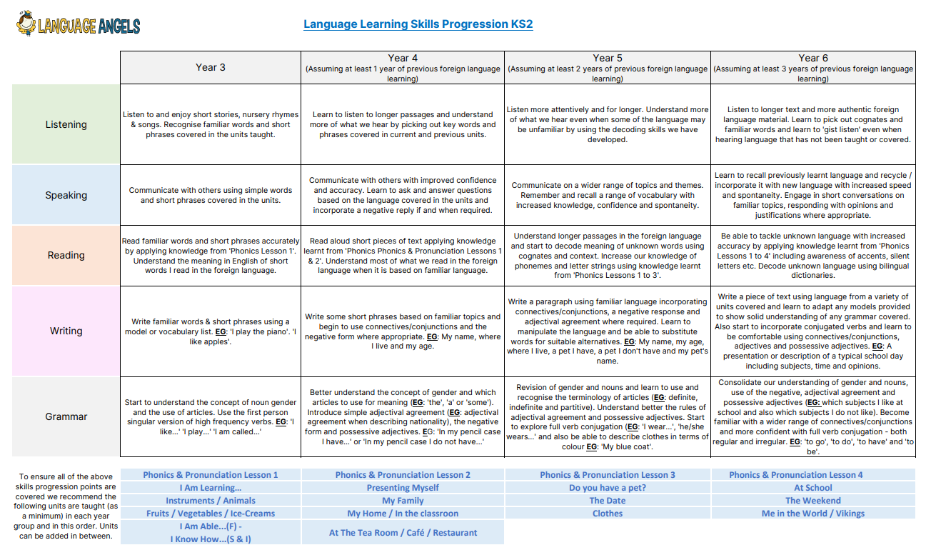

Early Learning units will start at basic noun and article level and will teach pupils how to formulate short phrases. By the time pupils reach Progressive units they will be exposed to much longer text and will be encouraged to formulate their own, more personalised responses based on a much wider bank of vocabulary, linguistic structures and grammatical knowledge. They will be able to create longer pieces of spoken and written language and are encouraged to use a variety of conjunctions, adverbs, adjectives, opinions and justifications.

Pupils will continuously build on their previous knowledge as they progress in their French learning journey through the primary phase. Previous language will be recycled, revised, recalled and consolidated whenever possible and appropriate.

Pupils will be aware of their own learning goals and progression as each unit offers a pupil friendly overview so that all pupils can review their own learning at the start and at the end of each unit. They will know and will be able to articulate if they have or have not met their learning objectives and can keep their unit learning intention sheets and unit core vocabulary sheets as a record of what they have learnt from unit to unit and from year to year.

The opportunity to assess pupil learning and progression in the key language skills (speaking, listening, reading and writing) and against the 12 DfE Languages Programme of Study for Key Stage 2 attainment targets is provided at the end of each 6-week teaching unit.

Primary Foreign Languages - Intent, Implementation & Impact Policy - Page 4 of 4

**Three Pillars of French learning at Stukeley**

**Phonics, Vocabulary, Grammar**

The Language Angels scheme of learning is based on these three pillars of language learning.

**Phonics**

Children will learn how to pronounce and read key sounds in French, building their French phonics knowledge with each unit.

**Language Angels Phonics Mat**

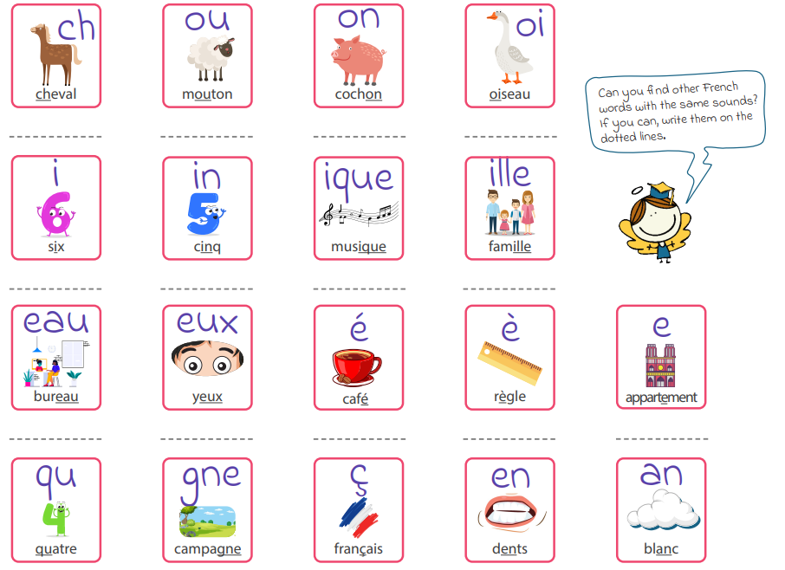

**Vocabulary**

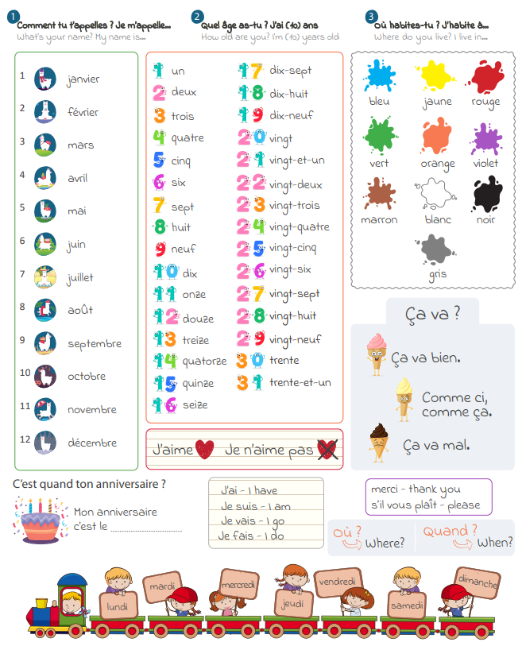

Above is the core vocabulary a child leaving Stukeley after 4 years of French learning should know.

Each unit has its own vocabulary sheet with pictures to aid remembering and is referred to in every lesson helping to consolidate vocabulary learning and support retrieval.

**Grammar**

Teachers will use the units to teach grammar at the appropriate level so that the children are able to formulate basic responses to authentic questions in French, and as their skills develop will be able to formulate more complex and personalised responses to questions.

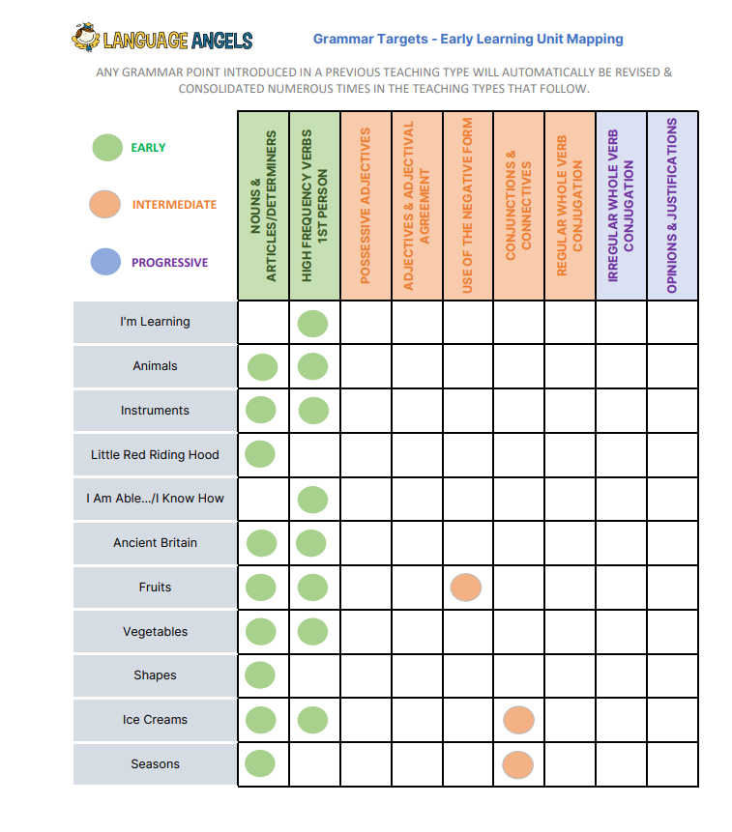

|  |  |  |  |  |
| --- | --- | --- | --- | --- |
| French Whole School Year Overview | | | | |
|  | Year 3 | Year 4 | Year 5 | Year 6 |
| Autumn 1 | Phonics and pronunciation lesson 1  Classroom instructions  I am learning French  26th September – European Day of Languages (Assembly focus) | Phonics and pronunciation lesson 2  Classroom instructions  Presenting myself  26th September – European Day of Languages (Assembly focus) | Phonics and pronunciation lesson 3  Classroom instructions  The date  26th September – European Day of Languages (Assembly focus) | Phonics and pronunciation lesson 4  Classroom instructions  The weekend  26th September – European Day of Languages (Assembly focus) |
| Autumn 2 | Cultural lesson 2 – Epiphany (6th January)  Animals  Extra : Merry Christmas (lesson 1) | My family  Extra : Merry Christmas (lesson 2) | My home  Extra : Merry Christmas (lesson 3) | Cultural lesson 5 – Remembrance Day (11th November)  Extra : Merry Christmas (lesson 4) |
| Spring 1 | Instruments | In the classroom | What is the weather? | Me in the world |
| Spring 2 | I am able… | Cultural lesson 3 – April Fool’s Day  Clothes | Cultural lesson 1- Nice Carnival (Feb)  Happy Easter (2 lessons) | Dictionary skills lessons |
| Summer 1 | Fruits | At the tearoom | At school | WW2 |
| Summer 2 | Ice cream | Goldilocks and the 3 bears | Grammar – regular verbs | Cultural lesson 4 – Bastille Day (14th July) |

Main units are highlighted

**Enrichment**

The school’s subscription to Language Angels also comes with pupil access to online songs and games to consolidate their language learning and increase their enjoyment of French.