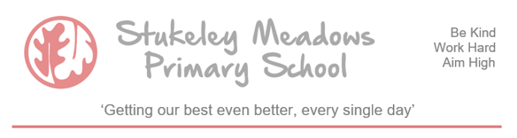

Stukeley Meadows Primary School Sports Team Selection Policy

Stukeley Meadows Primary School takes great pride in the fact that we compete in a range of sports fixtures, mainly focusing on running, football and netball. We typically have a fixture every single week of each school term. A considerable amount of work goes into facilitating these fixtures from fixture arranging, office admin time, liaising with other schools, white lining pitches, training teams and even washing kits!

Our challenge, as with most other schools, is to balance out our competitive values with our inclusivity. Where possible, when a fixture is announced we will ask the eligible children in that year group if they would like to be considered to be part of the team. Sports staff, teachers and SLT will then choose a team that is suitable to represent the school. We take a number of factors into account, such as
(but not limited to) experience and ability, prior opportunities to represent the school, behaviours in school and any additional curriculum pressures at that moment in time (e.g. SATs). When we make our team selection, all of the factors mentioned are made clear to the children.

Whether you are a professional sports person or a primary school child, disappointment and frustration at not being selected for the team is part and parcel of the opportunities available. The school have to make tricky decisions every time there is a fixture and we inevitably disappoint children. We ask families of Stukeley Meadows to please understand and help explain this recurring scenario to their children if/when that disappointment arises.

We want every Stukeley child to have the opportunity to represent the school at least once in their time with us. If you feel we are falling short of this, please get in touch and we can have a conversation.

